Data CO1

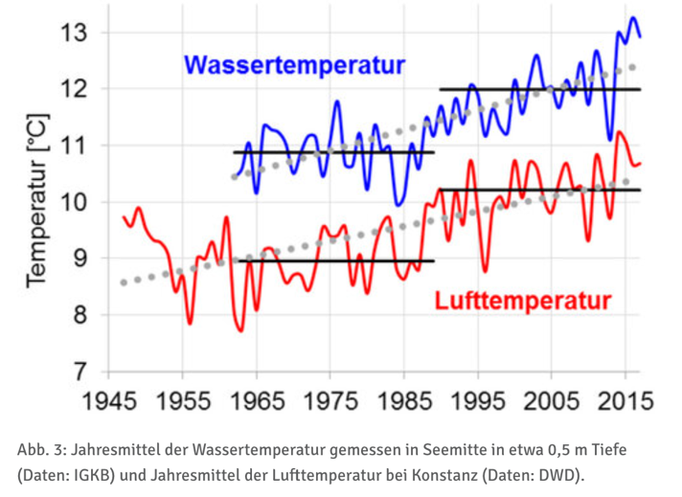
Temperature:

Datapoints from 1945-2015, the text states that the average water temperature from 1990-2017 was on average 1.2° higher than in the 3 decades before
Water circulation is decreasing because of milder winters and higher water temperatures.

Stuff to think about:
- How do we represent the seasonal differences or do we do this at all and just look at the fitted points and the rising of temperature in general?
- The temperature was measured in a depth of 0.5 meters, it will be cooler deeper and O2 Levels where measured at almost the deepest point of the lake

https://www.igkb.org/medien/faktenblaetter/zirkulation-im-bodensee-oktober-2018
https://umweltportal.baden-wuerttemberg.de/umweltdaten-bericht-2024/bodensee-gewaesserqualitaet

O2 Levels:
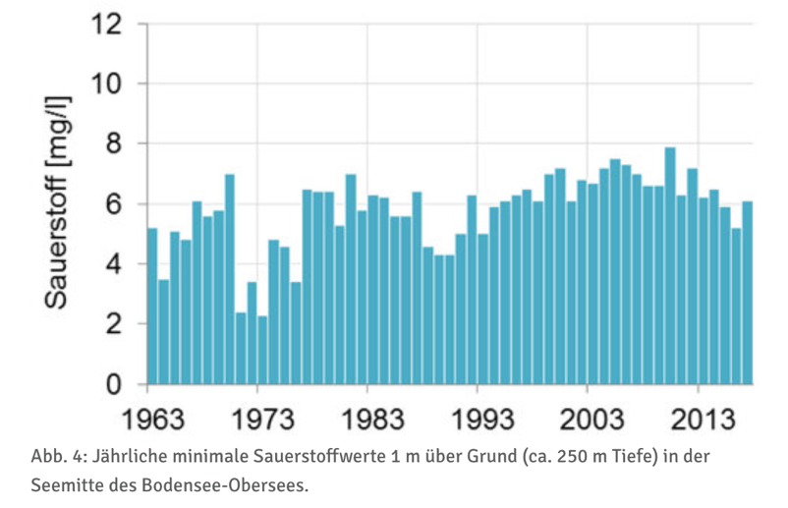

Datapoints from 1963-2013
The text states that for a large and deep alpine lake such as Lake Constance, maintaining a good oxygen supply of more than 6 mg/L in the deep water is essential. It provides enough oxygen for whitefish eggs and deep-water organisms and prevents nutrients and pollutants from being released from the sediment back into the lake water.

https://www.igkb.org/medien/faktenblaetter/zirkulation-im-bodensee-oktober-2018
https://umweltportal.baden-wuerttemberg.de/umweltdaten-bericht-2024/bodensee-gewaesserqualitaet

Nutrients:
Phosphor
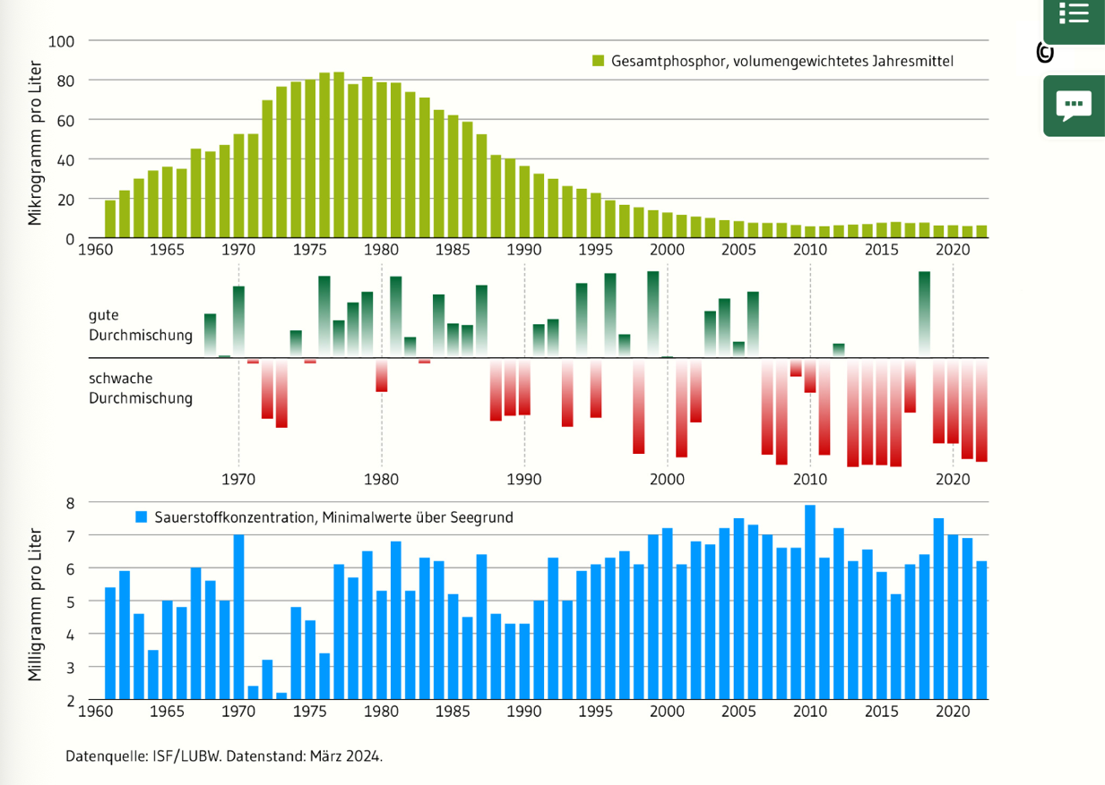

The text states that phosphor and O2 levels are connected, therefore also the overview.
Sewage treatment plant helped to reduce the phosphor levels

https://www.igkb.org/medien/faktenblaetter/phosphor-im-bodensee-oktober-2018

Nitrogen and chloride:

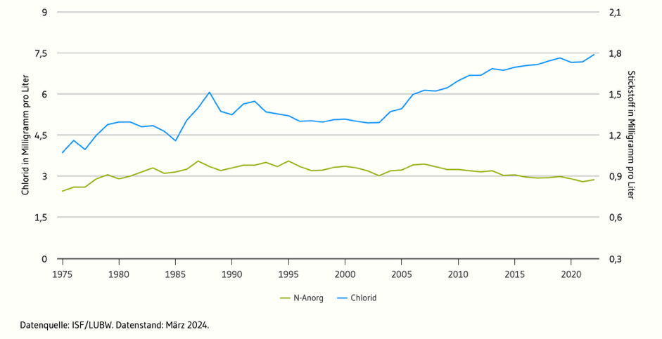

A significant proportion of the increase chloride levels is attributed to the use of road salt in winter
There is also information on Chlorophyll a and Phytoplankton on this website

https://umweltportal.baden-wuerttemberg.de/umweltdaten-bericht-2024/bodensee-gewaesserqualitaet

Fish:
Suggested species: whitefish (Felchen), important and characteristic for lake Constanze, a lot of fishing was done, sensitivity to temperature, O2 levels and phosphor concentration

Fishing of whitefish:
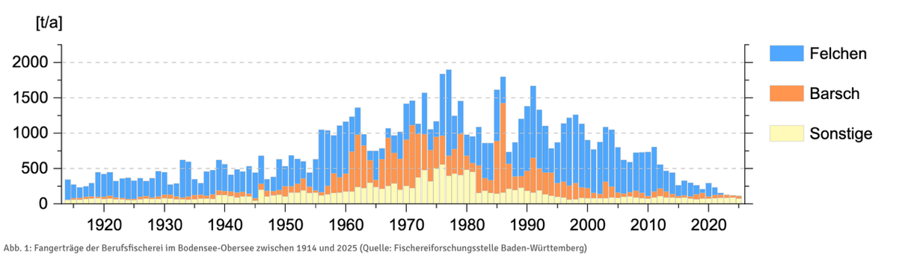
Important to note:
Since 2024 it is prohibited to fish whitefish in lake Constanze

https://www.igkb.org/daten-karten/fischereirechte-und-fischschongebiete
https://www.srf.ch/news/schweiz/mehr-felchen-im-bodensee-kompromiss-felchen-fangverbot-im-bodensee-wird-leicht-gelockert

